Summary of Coverage

Insured | Society for Association Managers (Master Policy)
Coverage | General Liability
Insurance Company | HDI Global Specialty SE (A A.M. Best)
Policy Period | 6/9/21 to 6/9/22
Rate | $6.00 per member plus taxes & fees
Who is covered | All enrolled member state associations and their individual members in good standing during work related activities including classroom coverage.
What are you covered for? | Claims made by negligent acts accidentally committed resulting in bodily injury, personal and advertising injury or property damage to others.  Individual member activities are those health, physical education, recreation and dance activities defined in each individual member’s job description
Policy Limits | General Aggregate | $1,000,000 (per member)
 | Products/Completed Operations | $1,000,000
 | Personal & Advertising Injury | $1,000,000
 | Each Occurrence | $1,000,000
 | Damage To Premises Rented To You | $300,000
 | Medical Expense | Excluded
 | Sexual Abuse/Occurrence | $50,000
 | Sexual Abuse Aggregate | $100,000 (per member)

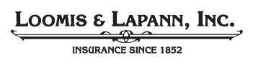
Prepared by Loomis & LaPann, Inc., Insurance Administrator of Society for Association Managers
800-566-6479 • www.loomislapann.com

