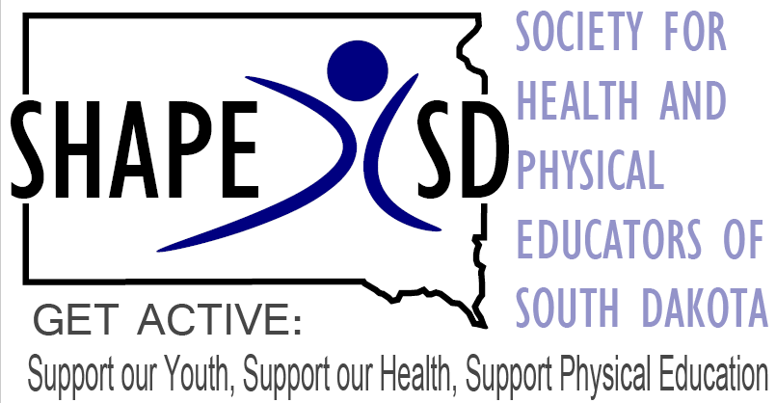 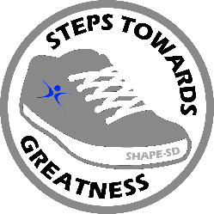

**SHAPE SD USE ONLY: Itinerary 2023. 10/24 Subject TO CHANGE!!   
November 1-3, 2023**

**NFAA Easton Yankton Archer Center Yankton, SD**

Best Western Kelly Inn  1607 E Highway 50; 605-665-2906

|  |  |  |  |
| --- | --- | --- | --- |
| **Wednesday, Nov 1** | | | |
| 8:00pm-?? | Social! GAME NIGHT?!  Boathouse is located at 301 E 3rd St, Yankton SD 57078 (605)653-1599 | | |
| 9 am to 5 pm | Archery! Thank you to Curt and The NASP archery team | | |
| 1:00 pm to 4 pm | Tennis | | |
| **Thursday, Nov 2 #SHAPESD23 ** Session descriptions below** | | | |
| 7:oo am-? | **Registration** (Court One) | | |
|  | **ROOM: Court Two** | | **ROOM : Court Four** |
| 8-8:50 | Jim Keyes & Ann Geisler Teaching Jitterbug Dance Moves to Middle and High School Aged Kids | | Owen Carlson Gopher Sport Action! Team Games to Boost Engagement |
| 9-9:50 | Shannon Tjaden OPEN Crash Course | | Jeff Pekny & Corey Whalen Pool Noodle-Hockey- Hockey with some Humor! |
| 10-10:50 | Danielle Cox: Pickleball Variations, Halo Ball, Sabakiball, Outdoor PE | | Carson Cody Modify! Encouraging Participation for All Through Modifications |
| 11-11:45 | **Deb Stephenson:** ROOM: Court Three  Beat the Drum | | |
| 11:45-12:45 | **LUNCH: Wraps & Chips**  ROOM: Community Center/Court One | | |
|  | Vendors: Intro  **Business Meeting:** -Update & Budget  **-Board open positions: Open for Nominations**  President Elect (open)  Executive Director (open)  Rec & Lifetime (ONE YEAR. 2024)  Physical Education: 2 openings  Health  Community Initiatives  Collegiate  Emerging Leaders:  Vote at Banquet: announcements will be made at end of Banquet | | |
| 1:00-1:50 | **Kym Hardin** Room: Court ThreeGet your Classroom Up and Moving! | | |
|  | **ROOM Court Two** | | **ROOM Court Four** |
| 2-2:50 | Wyatt Morse: Go for the Gold | | Nichole Buchholz Balance, Stride and Ride Toward Inclusion in PE Class |
| 3-3:50 | Amy Heuer: Making the connection between Outdoor Adventures and Student Mental Health | | Kelly Knutson Movement and Academics for Early Learners |
| Get ready for Banquet! | | | |
| 6:00 pm Social (Bring your own)  6:30 pm  (Meal) | **Banquet** ROOM: **Community Center/Court One ­­**  Food: Pork or Chicken, potatoes, salad, green beans  Thank you to SD Pork Council for supporting SHAPE SD  **Keynote:** **Deb Stephenson “5-6-7-8 Step Up”**  Recognition & Awards Presentations:   * Teachers of the Year   Announce Board members: meeting Friday 11:00 am  **Bring your own beverages** only water will be served | | |
| **See you in Spearfish, Nov. 6-7-8, 2024! At the Spearfish Holiday Inn!**  SHAPE SD would like to thank the following supporters:  cid:image002.png@01D202C9.DD4C1A80  OPEN Phys Ed, US Games & BSN Sports Accusplit  Dakota Sport, Neil Vokeman  South Dakota PORK Counsil  Outdoors Tomorrow Foundation  Lisa Weyer | Executive Director | All Kids Bike | 605-956-3877 | [#AllKidsBike](http://www.facebook.com/AllKidsBike)  GOPHER Sport: Owen Carlson [owencarlson@gophersport.com](mailto:owencarlson@gophersport.com)**|**855-826-4535  **Thank you, Morgan & the amazing team, at the NFAA Easton Yankton Archery Center**  **& Erica and team at the Best Western Kelly Inn!** | | | |
| **Friday, Nov. 3 #SHAPESD23 ** Session descriptions below** | | | |
|  | | | |
|  | **ROOM: Court Two** | **ROOM: Court Four** | |
| 8-8:50 | Kym Hardin OPEN Up your PE Possibilities | Erin Ahneman ABLE in Schools | |
| 9-9:50 | Wyatt Morse  New look New World | Cheryl Miller: America Red Cross Adult CPR Refresher | |
| 10-10:50 | **Deb Stephenson** Court Three  Fun and Easy Dances for the Non-Dancer | | |
| 11-11:50 | Jessie Daw Winning and Losing in PE and Sport | Randi Diehm: Best Practices Share Session | |
| 11:50 | Door Prizes! Travel Safely!  SHAPE SD Board Meeting 2023-2024 | | |



**Session Descriptions: #SHAPESD23**

**Erin Ahneman: ABLE in Schools**   
An inclusive K-12, peer-to-peer, scaffold curriculum. Focused on all learners working in coordination with each other in a PE class. ABLE focuses on skill modification, adaptation, social, and emotional learning. Removing barriers for the PE teachers- lesson planning or enhance current curriculum; able™ aligns to National Standards. Serving special needs students with their peers. Interactive and engaging!

Gamification in 2024! Gamifying movement for grades 7-12! Ability to compete against other schools and classes across the upper Midwest.

**Nichole Buchholz: All Kids Bike.org  
Balance, Stride and Ride Toward Inclusion in PE Class** There are many PE activities that attempt to provide an inclusive environment. However, very few provide true inclusion giving ALL students the opportunity to participate and gain a sense of achievement. In 8 lessons, the All Kids Bike Program provides EVERY student with equitable access to the childhood rite of passage of riding a bike. The program teaches balance before pedaling which leads to success! It also enhances confidence and boosts physical and mental development.

**Carson Cody: Modify! Encouraging Participation for All Through Modifications**

This presentation goes over three different situations that can make student participation difficult: working with a diverse needs student, having a class with low participation, and having minimal space and/or equipment. We will go over each topic and cover a handful of activities that can increase participation for all involved including the use of closed skills, roles in games, and being creative with equipment. After the presentation, attendees should leave with new ideas of how to get their classes engaged.

**Danielle Cox**  
Pickleball Variations, Halo Ball, Sabakiball, Outdoor PE

Pickleball 4 square, paddle zlam, paddle ball, 3 pass pickleball

Halo ball–set up, rules, quick play

Sabakiball- rules and quick play

Outdoor PE- description of what I do with my students

**Jessie Daw: Winning and Losing in PE and Sport**

This presentation will explore the role of winning and losing in both PE and youth sport. Competition and its role in both contexts are multifaceted. On one hand, competition can motivate youth to work harder and strive for goals. On the other hand, the emphasis on winning can have negative consequences like fear of failure and the development of competitive anxiety. This presentation will examine how to balance the pursuit of winning with other values, like sportsmanship, teamwork, and personal growth, as well as exploring how losing can serve as a valuable growth opportunity in each context (i.e., PE and sport).

**Randi Diehm: Best Practices Share Session**

We are all on our own island in our work and this session is geared at providing networking, collaborating, and comradery. As this is all about YOU, there is no formal agenda for this session. Bring in your questions and best practices!

**Kym Hardin: Get your Classroom Up and Moving!**Looking for easy ways to get your classroom moving? We will dive into the importance of moving while learning and learning simple ways to incorporate movement into everyday lessons!

**Kym Hardin: OPEN Up your PE Possibilities**

In this active session we will participate in instant activities to start your classes as well as active classroom and recess games. These activities can be used throughout the year!

**Amy Heuer: Making the connection between Outdoor Adventures and Student Mental Health**   
Our mission is to get more students outdoors and to improve the health and well-being of all participants. Teaching outdoor adventure activities can be a life-changing experience for your students and is appropriate for any grade level. Delve into the mental health research around outdoors adventures and discover the many benefits for your students, teachers, school, and community. Explore how Outdoors Tomorrow Foundation can help you start your adventure, and plan to participate in some of your own **ADVENTURE** activities during the session! We will share resources and information on Outdoor Adventure teaching best practices, sample lessons, and how to initiate or expand your own Outdoor Adventure Program.

**Jim Keyes & Ann Geisler: Teaching Jitterbug Dance Moves to Middle and High School Aged Kids**

This presentation will help you feel comfortable enough to teach jitterbug in your middle and high school classrooms. I will teach nine different moves that are easy to remember, and the kids will enjoy it. The jitterbug that I teach is what I consider the more updated version that high school and college aged kids are doing today.

**Kelly Knutson: Movement and Academics for Early Learners**

Integrating academics and movement in education can have numerous benefits for learners of all ages, including improved engagement, retention, and overall well-being. This interactive session will provide many ways to incorporate movement skills with academics.

**Wyatt Morse: New Look New World**

This session will highlight some new look PE games to enhance your program. We will also showcase some games from around the world. These games can be modified to help fit any budget and can be played or adapted to meet the needs of all students K-12.

**Wyatt Morse: Go for the Gold**  
Participates in this session will go through various activities as they compete for medals in a sample of an Olympic Games unit. Can be used at any grade level. Get students excited to participate and build school culture and togetherness during this fun unit.

**Cheryl Miller: American Red Cross Adult CPR Refresher**  
Need a refresher in CPR? This session will provide a quick review of the appropriate steps to take in an emergency…demonstrate proper technique for conventional mouth to mouth CPR…provide an opportunity for hands on practice.

**Owen Carlson: Gopher Sport Action! Team Games to Boost Engagement**

An action-packed workshop featuring team games that are class-oriented, teacher-friendly, and align with national physical education standards. These high-energy games are sure to get students moving while also keeping them engaged.

**Jeff Pekny & Corey Whalen: Pool Noodle-Hockey- Hockey with some Humor!**A Winter sport to teach the concepts of hockey in a gym. It’s a twist on a winter sport and it provides exercise and some humor along the way. My students have a blast playing this each and every year!

**Deb Stephenson:** **Beath the Drum**  
Join us as we explore Fitness Drumming. In the session, attendees will learn drumming techniques, participate in routines, and experience the benefits of adding this cardio rhythmic unit to your PE curriculum.

**Deb Stephenson: Fun and Easy Dances for the Non-Dancer**  
Get excited about teaching dance to your students. You may be an expert or a novice, but there is something for everyone. Deb will share a variety of easy to learn, easy to teach, dances. Strategies will be shared to get your students active and engaged. Guaranteed to make you smile as you move.

**Shannon Tjaden: OPEN Crash Course**

Session will describe the OPEN curriculum and show how easy it is to integrate OPEN into your current curriculum. This fast-paced session will get teachers exposed to OPEN’s outcomes-based teaching and learning tools through an active learning environment. Participants will be exposed to OPEN activities and gain access to over 5,000 FREE lesson plan documents!